.0EETC-1314
Lab #2
AC Circuit: Phase Angle & Phase Shift

Student Name: _________________________________ Date: ___________

Instructor Signature:_________________________________ Date: ___________

Point Assignment: ________________________

PURPOSE:

The purpose of this laboratory experiment is to familiarize the student with phasor principles and phase shifts. The student will compute and measure the voltage, current, impedance, and phase shift for an RC circuit.

PROCEDURE:

- (10%) For the circuit shown in figure #1, the voltage source is a 5V RMS, 500 Hz, 0º AC
Signal driving a 330 Ω resistor in parallel with a 1μF capacitor. Perform calculations to find the following values (include the phase angle):

  - Resistor Current, I_{R1} = ____15.15 mA_______ Angle = _____0_______

  - Capacitor Current, I_{C1} = ____15.71 mA_______ Angle = ______90_______

  - Total Current, I_{T} = _____21.82 mA______ Angle = _____46________

Show all the calculation steps in your report. Verify your calculations for the currents using MULTI-SIM. [Be sure to use an RMS ammeter for the measurements.] Record the results of your calculations in the table shown below and provide a screen-shot of the Multi-Sim circuit and measurements in your report.
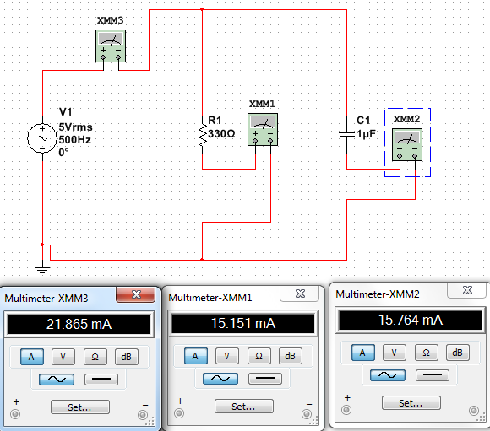

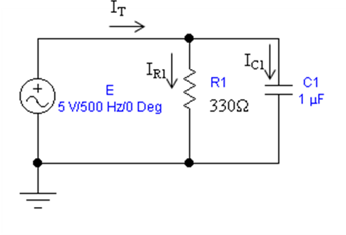
Figure #1 Parallel AC Circuit

Table #1: Calculated and Measured RMS Current
Variable | Calculated RMS  Current (mA) | Measured RMS  Current (mA) | Measured RMS  Currrent multi sim
I_{R1} | 15.2 | 15.3 | 15.2
I_{C1} | 15.7 | 15.5 | 15.8
I_{T} | 21.8 | 21.7 | 21.9

- (15%) Construct the circuit of figure #1 on the NI-ELVIS bread-board. Set the function
generator to 7.07 V Peak (i.e, 5 V RMS) and connect the source to a resistor and capacitor as shown. Using an RMS ammeter, measure |I_{R1}|, |I_{C1}|, and |I_{T}|. Record the measurements in Table #1 above. (Note: the multi-meter simply measures the magnitude of the current.)

  - Do the measured magnitudes of current flow through the resistor and capacitor add up to the magnitude of the total current measured from the source (i.e., |I_{R1}|+|I_{C1}|=|I_{T}|)?

NO

  - Why or why not?

Because the phase is different

- (25%) For the circuit shown in Figure #2, the voltage source is a 5V RMS, 500 Hz, 0º AC Generator driving a 330 Ω resistor in series with a 1μF capacitor. Perform the following calculations:

  - Angular Velocity, ω = ____1000 * 3.14_______

  - Capacitive Reactance, X_{C} = _____318.31_______

  - Total Impedance, Z_{T} = ____458.5____ Angle __-44________

  - Circuit Current, I_{T} = _____10.91__ Angle _____44______

  - Resistor Voltage, V_{R1} = ___3.6____ Angle ___44______

  - Capacitor Voltage, V_{C1} = ____3.47___ Angle __-46_______

  - Write the sinusoidal time domain equation for each voltage, E, V_{R}, and V_{C}, using v(t) = V_{p}sin(ωt + θ). Plot the results using a spreadsheet (at least 11 points, including point zero) and attach the plot to the lab report.

E(t)=7.07sin(1000*3.14*t)V
Vr(t)=5.09sin(1000*3.14+44)V
Vc(t)=4.91sni(1000*3.14*t-46)V

 | VOLTAGE | RESISTOR VOLTAGE | CAPASITOR VOLTAGE
 | 7.07sin(1000*3.14*t)V | 5.09sin(1000*3.14*t+44)V | 4.91sin(1000*3.14*t-46)V
0 | 0 | 3.53564681 | -3.528540911
0.0002 | 4.153819607 | 5.012349932 | -0.849310133
0.0004 | 6.722576386 | 4.576382234 | 2.154010289
0.0006 | 6.72605423 | 2.394105342 | 4.335378397
0.0008 | 4.162926023 | -0.701742128 | 4.862402361
0.001 | 0.011260056 | -3.529810671 | 3.533974243
0.0012 | -4.144702654 | -5.010932977 | 0.857011105
0.0014 | -6.719081489 | -4.579925161 | -2.146980304
0.0016 | -6.729515013 | -2.4012562 | -4.331701983
0.0018 | -4.17202188 | 0.693712047 | -4.863482406

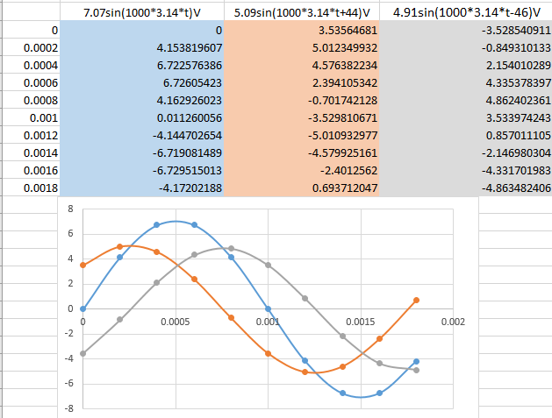
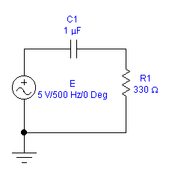
Figure #2 Series Circuit

- (25%) Construct the circuit of figure 3 using the NI-ELVIS bread-board and
components. Use the NI-ELVIS oscilloscope to observe the voltage across the AC Generator (Channel #1) and the voltage across the resistor R₁ (Channel #2) simultaneously.

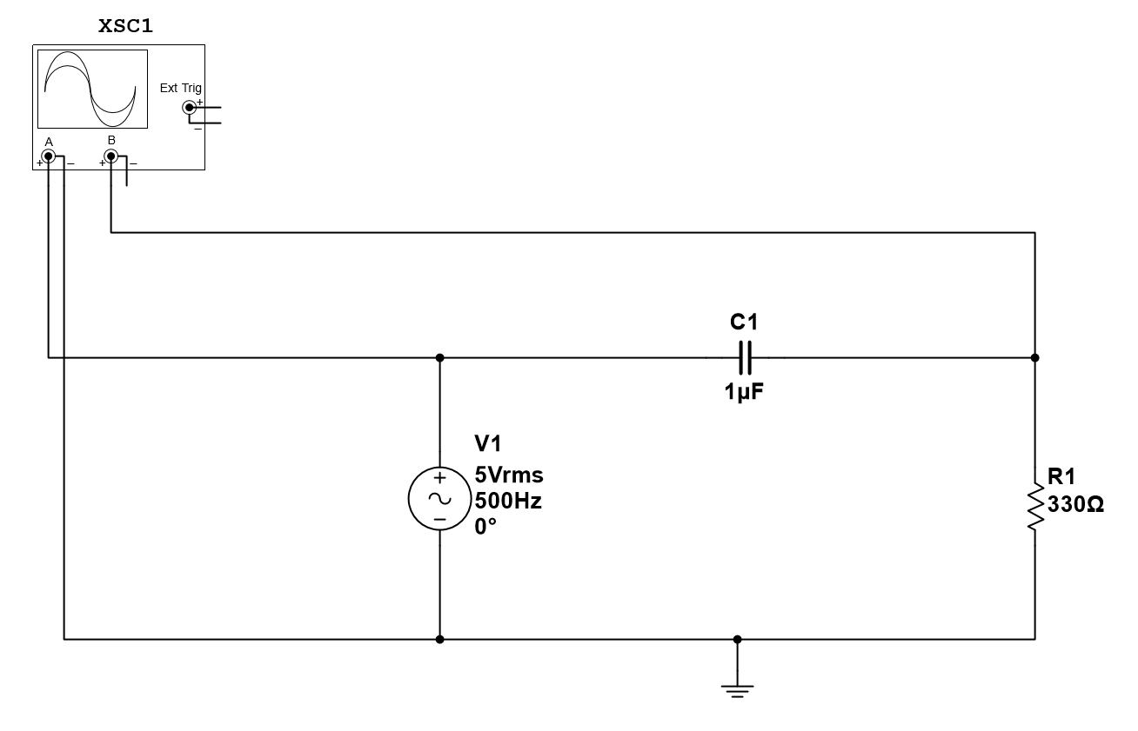
Figure #3 – Oscilloscope Connections for Channel 1 and Channel 2
Take an electronic snapshot of the waveforms to be included in the report. Perform the following measurements:
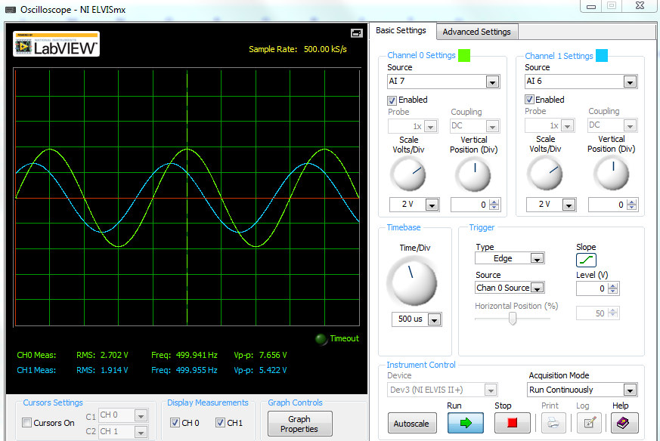
  - AC Generator Peak Voltage, E_{peak} = ____7.64Vp________

  - AC Generator Frequency, f = _____500 Hz____

  - AC Generator Period, T = _____2ms______

  - Time Diff. between the Generator and Resistor Voltages, ΔT_{RE} = ___252us___

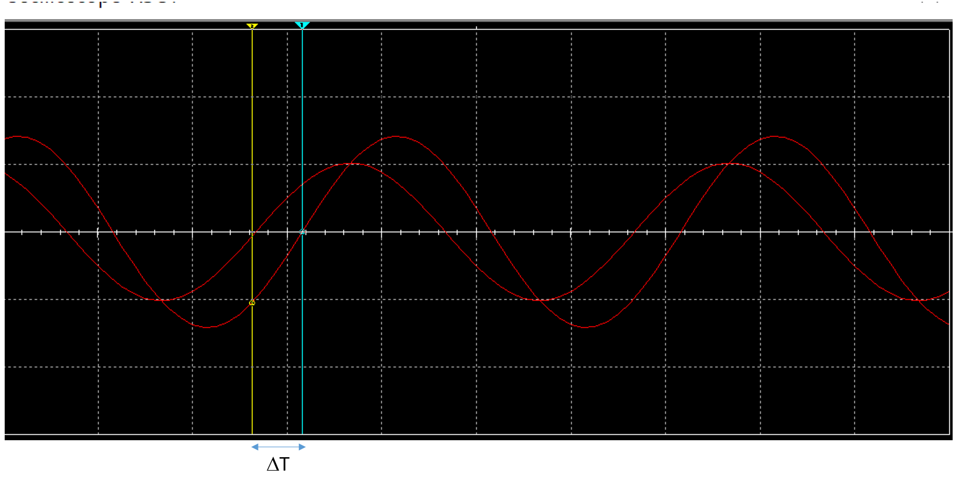
Figure #4 – Illustration of how to measure the time difference between waveforms.

  - Peak Voltage of the Resistor, V_{Rpeak} = ___2.71________

  - Resistor Voltage Phase Shift, Θ_{ΡΕ} = 360 x [ΔT_{RE}/T] = ____45.36______

  - Take 11 measurements of both the generator voltage and resistor voltage waveforms. The generator voltage waveform begins at time value of zero, so the first resistor voltage time measurement will be negative time. Plot the results using EXCEL.

 | Voltage | Resistor voltage
0 | 0 | 3.6
0.0002 | 4.4 | 5.32
0.0004 | 7.26 | 4.88
0.0006 | 7.28 | 2.6
0.0008 | 4.46 | -0.724
0.001 | 0 | -3.7
0.0012 | -4.38 | -5.3
0.0014 | -7.28 | -4.9
0.0016 | -7.3 | -2.58
0.0018 | -4.5 | 0.726
0.002 | 0 | 3.72

- (25%) Swap the location of the resistor and capacitor for the circuit as shown.

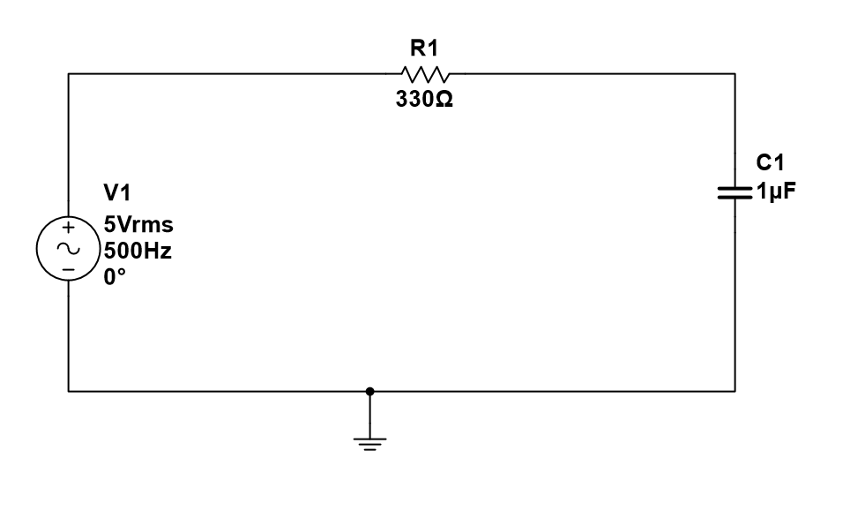
Figure #5 – Capacitor and Resistor Swapped

Use the NI-ELVIS oscilloscope to observe the voltage across the AC Generator (Channel #1) and the voltage across the capacitor C₁ (Channel #2) simultaneously.

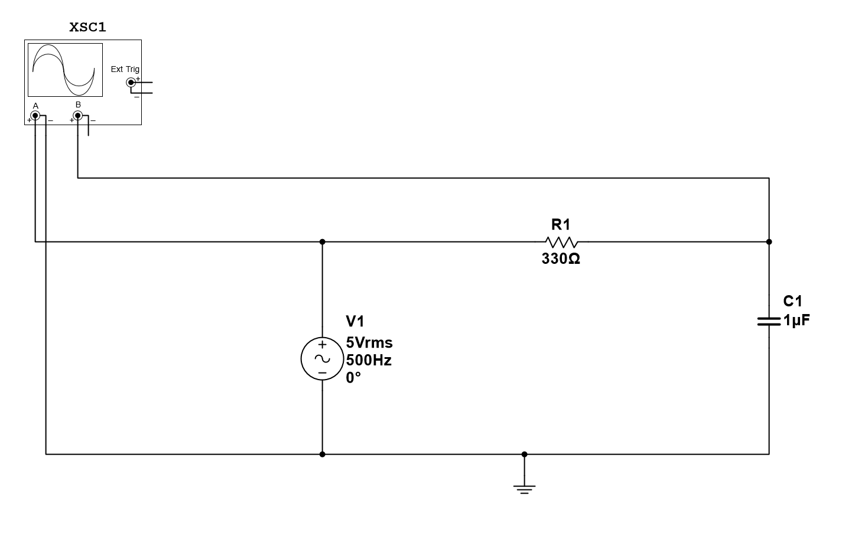
Figure #6 – Generator and Capacitor Voltage Measurement Connections

Take an electronic snapshot of the waveforms to be included in the report. Perform the following measurements:

  - Time Diff. between the Generator and Capacitor Voltages, ΔT_{CE} = __254 us

  - Peak Voltage of the Capacitor, V_{Cpeak} = ____4.15 Vpk_______

  - Capacitor Voltage Phase Shift, Θ_{CE}= 360 x [ΔT_{CE}/T] = ____45.72 deg._________

  - Calculate the phase shift between the capacitor voltage and current,

Θ_{C} = Θ_{RE} + Θ_{CE} = ____91.08 deg.__________

[Note: Why use the resistor voltage angle? The resistor voltage is proportional to the current flowing in the circuit, so the current will have the same phase angle as the resistor voltage.]

  - Take 11 measurements of the capacitor voltage waveform relative to the generator waveform, which has a phase angle of zero. (The first time point of the capacitor voltage will be a value greater than zero since it begins to the right of the generator waveform.) Plot the results using EXCEL.

 | Voltage | Capastor voltage
0 | 0 | -3.2
0.0002 | 4.4 | -0.822
0.0004 | 7.26 | 2.5
0.0006 | 7.28 | 4.82
0.0008 | 4.46 | 5.28
0.001 | 0 | 3.74
0.0012 | -4.38 | 0.798
0.0014 | -7.28 | -2.52
0.0016 | -7.3 | -4.84
0.0018 | -4.5 | 5.32
0.002 | 0 | -3.78

  - From the lab results, generalize a statement about the relationship between the capacitor current and capacitor voltage.

